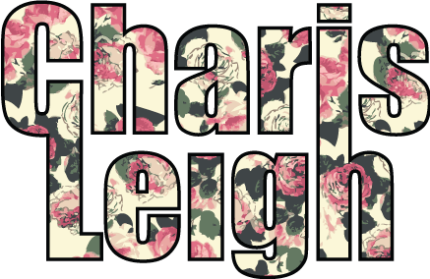
Resume

Charis Leigh Bridges
618-789-3067
Charis@CharisLeigh.com

Website: CharisLeigh.com
Qualifications
Computer Skills: Adobe Illustrator, Adobe Photoshop, Micrografx Designer, Microsoft Office, Excel, Gerber System
Related Experience
Aquarius Ltd. 2009-Present St. Louis, MO
Freelance Accessory Designer
- Design cold weather accessories (hats, gloves, scarves)
- Trend researching and presentation boards
- Sending tech packs and specs to China and overseeing samples
- Working in very high volume with tight time and cost constraints
- Domestic and International travel to sample rooms, factories, trend shopping, and meetings
Accessory Exchange 2006-2008 New York City, NY
Associate Handbag Designer for Private Label Division
- Design Handbags for Target (Xhileration, Merona, Mossimo, and Converse One Star), Wal-Mart (No Boundaries, Faded Glory, White Stag, and George), Payless (Airwalk and American Eagle)
- Trend Research for each new season
- Come up with new concepts for handbag lines
- Sending tech packs and specs to China and overseeing samples
- Working in very high volume with tight time and cost constraints
- Domestic and International travel to sample rooms, factories, trend shopping, and meetings
Designer Loft Productions 2005-2007 New York City, NY
Brand Management
- Worked directly with designers who are looking to take their collections to the US
- Setting up and attending photo shoots for company advertisements and Look Books
- Preparing designers for market twice a year
- Dress selection for editorials in national magazines
- Producing runway shows for designers
- Worked on launch of Kirstie Kelly for Disney Fairytale Weddings
Production Work
Fashion Shows
- Kirstie Kelly for Disney Fairytale Weddings, Adele Wechsler, Manale Paris, Yumi Katsura
- Bridal Shows at the Pierre and Waldorff Astoria in New York City
- Runway Remix 2005 Student Director

Education Art Institute of Fort Lauderdale
Fashion Design Major
Graduated June 2005
Associate of Science
Scholarship Study abroad in Germany at the Fachhochschule School of Design
Studied coat design, corset design, as well as other garment designs and constructions
Awards The Award for Highest Achievement in Fashion Design
Best Children’s Wear
Best Dance Wear

